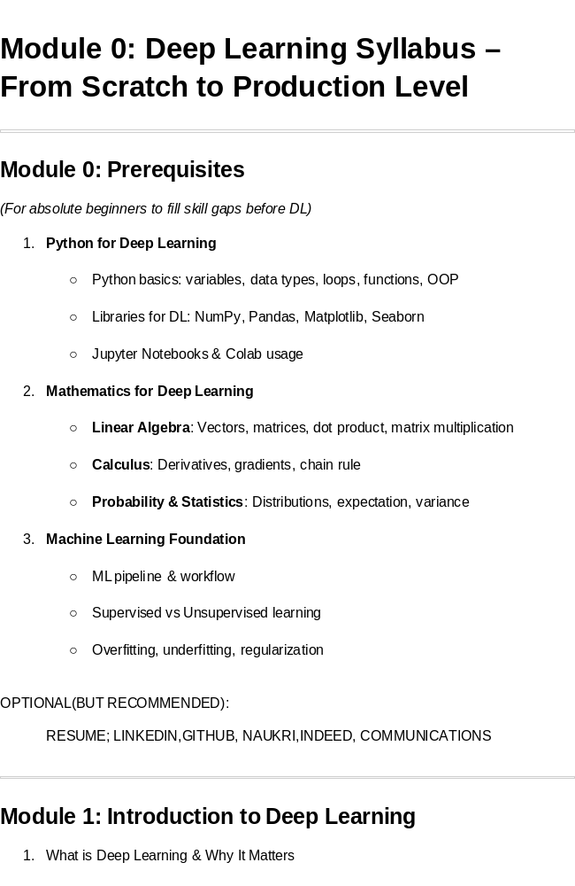🎓 Course: Deep Learning & Generative AI from Scratch (High-Level → Low-Level Approach)

💡 Course Vision
Students first see what AI can do, then use AI tools, then understand how it works, and finally build & deploy their own AI models.
Designed for both technical (coding) and non-technical (conceptual) learners.

🌍 Real-World Hook
Question:
- How does Netflix know what show you’ll love next?
- How does a phone unlock by r ecognizing your face?
- How does ChatGPT generate human-like answers?
All these applications learn patterns from data — images, words, numbers — using Neural Networks.

💡 Introduce Topic as a Solution
Traditional programming required explicit rules — but real-world data is too complex for rule-based logic.
Neural Networks solve this by learning from examples, much like the human brain learns from experience.

🧭 Stage 1: Inspire — “What AI Can Do”

🎯 Goal: Spark curiosity with real-world AI examples.

📘 Topics:
- What is AI really doing in the world?
- Everyday AI applications
- Business use cases
- Personal productivity use cases

💼 Real-World Examples:
Area | AI Use Case | Example Tool / Company
Text | Chatbots, content writing | ChatGPT, Claude, Gemini
Image | Art, design, advertising | Midjourney, Leonardo.ai, Canva AI
Audio | Voiceovers, transcription | ElevenLabs, Whisper
Video | Marketing, education | Runway ML, Pika Labs, Synthesia
Vision | Surveillance, healthcare | Tesla Autopilot, DeepMind for Eye Disease
Recommender | E-commerce | Netflix, Amazon

🧩 Class Activity:
- Ask students to list 5 AI tools they’ve seen or used.
- Watch short demo videos from YouTube: “AI Tools That Change the World 2025”.
- Discuss: “How could this AI help a business or your daily life?”

🧠 Stage 2: Explore — “How to Use AI Tools”

🎯 Goal: Make students comfortable using AI tools hands-on.

📘 Topics:
- How to talk to AI: Prompting 101
- Explore top AI tools for text, image, audio, video, code
- Understand input-output behavior

🧰 Tools & Links:
Type | Tool | Link | Use Case
Text | ChatGPT | https://chat.openai.com | Writing, Q&A
Text | Claude | https://claude.ai | Long document reasoning
Image | Leonardo | https://leonardo.ai | Product design, concept art
Image | DALL·E 3 | https://openai.com/dall-e-3 | AI art generation
Audio | ElevenLabs | https://elevenlabs.io | Text-to-speech
Audio | Whisper | https://openai.com/research/whisper | Speech-to-text
Video | Pika Labs | https://pika.art | Text-to-video
Avatar | HeyGen | https://www.heygen.com | Talking avatars

- https://chatgpt.com/c/68eb6b49-e8c0-8321-99a6-d5df45433406
- https://www.blackbox.ai/
- https://huggingface.co/spaces/frogleo/AI-Clothes-Changer
- https://creator.nightcafe.studio/studio?open=creation&panelContext=%28jobId%3AcmBDUUaqYDuBue4Wn8Vj%29
- https://www.imagine.art/dashboard/video/tool/text-to-video
- https://gemini.google.com/app/54c0ecdfab3ddc95
- https://aistudio.google.com/apps/bundled/genai_videos_with_veo?showPreview=true&showAssistant=true
- https://aistudio.google.com/projects
- https://replicate.com/google/veo-3-fast?input=python
- https://openai.com/index/dall-e-3/
- https://flowgpt.com/
- https://openai.com/api/pricing/

https://huggingface.co/docs/transformers/v4.57.0/en/main_classes/pipelines#transformers.Pipeline.model
- https://platform.openai.com/settings/organization/api-keys

- https://ollama.com/search
- https://lmstudio.ai/
- https://huggingface.co/microsoft/VibeVoice-1.5B

- 0. First_class_Code_demo_ai_models.ipynb
- https://playground.tensorflow.org/
- https://www.tensorflow.org/

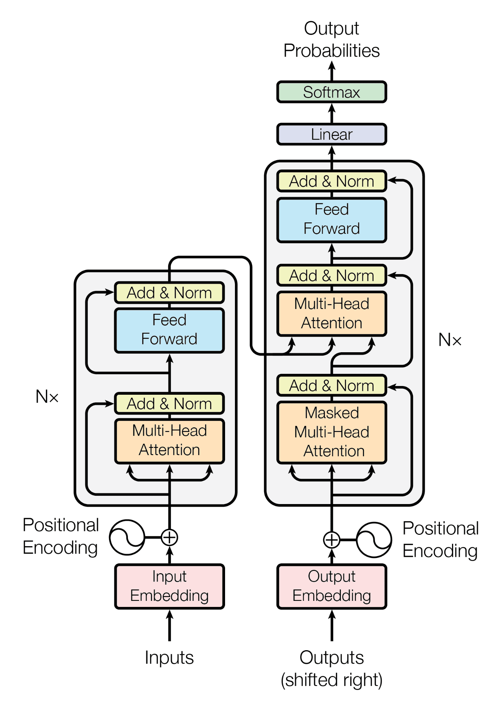

🧩 Mini Projects:
- Create a LinkedIn post using ChatGPT and rewrite it in 3 tones (formal, funny, simple).
- Design a brand logo in Leonardo.ai.
- Convert a paragraph to voice narration using ElevenLabs.
- Generate a product promo video using Pika Labs.

🧬 Stage 3: Empower — “How AI Works Behind the Scenes”

🎯 Goal: Simplify core AI concepts visually (no coding yet).

📘 Topics:
- AI vs Machine Learning vs Deep Learning vs Generative AI
- How AI learns (training with data → model → prediction)
- What is a Neural Network (with analogy: “student learning from examples”)
- Difference between traditional programming and AI

📊 Visualization Tools:
- Google Teachable Machine – Train a model with webcam images
- TensorFlow Playground – Visualize neurons and layers
- Hugging Face Spaces – Try pretrained models easily

🧩 Class Demo:
- Train a model on Teachable Machine to recognize happy vs sad faces using webcam.
- Explain concept of data, training, and accuracy in simple terms.
💬 Key Analogy:
“AI learns just like humans — it sees examples, adjusts its understanding, and improves with feedback.”

💻 Stage 4: Local AI — “Running AI on Your Computer”

🎯 Goal: Bridge from AI apps to local models.

📘 Topics:
- Difference between cloud AI and local AI
- What is an LLM (Large Language Model)
- How to run models on your PC (offline AI)

🧰 Tools & Links:
Tool | Link | Description
Ollama | https://ollama.ai | Run local LLMs like Llama 3, Mistral
LM Studio | https://lmstudio.ai | GUI for local models
Stable Diffusion | https://stability.ai | Run image generation locally
Whisper | https://github.com/openai/whisper | Speech recognition locally

🧩 Demo Project:
- Run a local chatbot using Ollama (ollama run llama3).
- Generate images offline with Stable Diffusion Web UI.

🎨 Stage 5: Customize — “Controlling AI Output”

🎯 Goal: Teach prompt engineering and fine-tuning.

📘 Topics:
- What is prompt engineering
- Prompt structure: Role → Task → Context → Example
- Techniques: few-shot prompting, chain-of-thought, temperature
- Introduction to Fine-Tuning
- RAG (Retrieval-Augmented Generation) for custom data

🧰 Tools:
- ChatGPT Playground
- FlowGPT Prompt Library
- Hugging Face Hub
- LangChain
- LlamaIndex

🧩 Mini Projects:
- Design a customer support chatbot prompt for a travel agency.
- Fine-tune an open-source model (e.g., DistilBERT) for sentiment analysis on movie reviews.
- Build a RAG-based PDF chatbot using LangChain (non-tech can use ChatGPT Code Interpreter to simulate).

⚙️ Stage 6: Create — “Building Models from Scratch”

🎯 Goal: Move to low-level (for technical learners).

📘 Topics:
- Neuron, weight, bias, activation function
- Forward and backward propagation
- Building ANN using TensorFlow or PyTorch
- CNN for images, RNN for text
- GAN basics (Generator vs Discriminator)

🧰 Tools & Libraries:
- TensorFlow
- Keras
- PyTorch
- Google Colab – free GPU environment

🧩 Coding Labs:
- Build MNIST digit classifier (ANN).
- Build dog vs cat image classifier (CNN).
- Build sentiment analysis model (RNN/LSTM).
- Train simple GAN to generate handwritten digits.

🎭 Stage 7: Generative AI in Action

🎯 Goal: Show creative side of Deep Learning.

📘 Topics:
- Text generation (GPT, Llama)
- Image generation (Diffusion, GANs)
- Voice generation (TTS, cloning)
- Video synthesis
- Multimodal AI (text + image + audio)

🧰 Tools:
Category | Tool | Link
Text | OpenAI GPT | https://platform.openai.com
Image | Stable Diffusion | https://stability.ai
Video | Runway, Pika Labs | https://runwayml.com, https://pika.art
Audio | ElevenLabs | https://elevenlabs.io
Multimodal | Hugging Face models | https://huggingface.co/models

🧩 Projects:
- Build a ChatGPT clone using OpenAI API or Ollama.
- Generate AI art portfolio.
- Create a text-to-video ad using Runway.
- Generate voice narration for that video.

☁️ Stage 8: Deploy — “Bring AI to the Real World”

🎯 Goal: Make deployable AI apps.

📘 Topics:
- Using Streamlit or Gradio for UI
- Connecting backend AI model (API or local)
- Hosting (Hugging Face Spaces, Render, Docker)

🧰 Tools:
Tool | Link | Purpose
Streamlit | https://streamlit.io | Build interactive apps
Gradio | https://gradio.app | Simple AI app interface
FastAPI | https://fastapi.tiangolo.com | Backend API
Hugging Face Spaces | https://huggingface.co/spaces | Free AI deployment
Docker | https://www.docker.com | Containerization

🧩 Projects:
- Deploy your chatbot on Hugging Face.
- Create a Streamlit app for image generation.
- Dockerize an LLM + UI app.

⚖️ Stage 9: Ethics, Bias & Careers

🎯 Goal: Responsible use of AI + career readiness.

📘 Topics:
- Bias and hallucination in AI
- Deepfake and misinformation
- AI transparency and regulation (EU AI Act)
- Future of AI careers and roles

💼 AI Career Paths:
Role | Description
Data Scientist | Data analysis, ML models
AI Engineer | Build and deploy AI systems
Prompt Engineer | Design AI interactions
AI Product Manager | Bridge between tech and business
AI Researcher | Develop new AI algorithms

🧩 Activity:
- Debate: “Should AI replace humans in creative jobs?”
- Quiz: “Which AI role fits you best?”

🗓️ Optional: 12-Week Teaching Plan
Week | Topic | Focus
1 | AI in the Real World | Inspire
2 | Exploring AI Tools | Hands-on usage
3 | How AI Works | Visual understanding
4 | Local AI | Running models offline
5 | Prompt Engineering | Control outputs
6 | Fine-Tuning | Personalize AI
7 | Neural Networks | Foundation
8 | CNN/RNN | Deep architectures
9 | GANs & Diffusion | Generative models
10 | Build AI App | Integration
11 | Deploy AI App | Hosting & UI
12 | Ethics & Careers | Responsible AI

Perfect ✅ — let’s now apply your Master Teaching Prompt to a core topic:
“Introduction to Neural Networks (Deep Learning Foundations)”

🧠 Lesson: Introduction to Neural Networks

🏁 Lesson Introduction
Welcome to the world of Neural Networks — the foundation of Deep Learning and Generative AI.
Today we’ll explore how machines learn patterns just like humans.

📋 Today’s Mini Agenda:
- Real-world Motivation
- What Are Neural Networks?
- Why & When to Use Them
- How They Work (Step-by-Step)
- Practical Example with Dataset
- Business Use Case
- Practice Questions
- Case Study
- Streamlit Interface Demo
- Interview Preparation

🌍 Real-World Hook
Question:
- How does Netflix know what show you’ll love next?
- How does a phone unlock by recognizing your face?
- How does ChatGPT generate human-like answers?
All these applications learn patterns from data — images, words, numbers — using Neural Networks.

💡 Introduce Topic as a Solution
Traditional programming required explicit rules — but real-world data is too complex for rule-based logic.
Neural Networks solve this by learning from examples, much like the human brain learns from experience.

📘 Theory Explanation

🔹 What is a Neural Network?
A Neural Network is a system of interconnected neurons (nodes) that learn to recognize patterns from data.
Each neuron receives inputs, processes them, and passes signals forward.
Definition (for interview):
A Neural Network is a computational model inspired by biological neurons, designed to automatically learn relationships between input and output data using layers of interconnected nodes.

🔹 Why We Use Neural Networks
- To automate pattern recognition
- Handle non-linear relationships
- Power image, text, and speech AI systems
- Enable self-learning and adaptation

🔹 When to Use Neural Networks
✅ When data is large and complex
✅ When relationships are non-linear
✅ For problems like image, speech, text, or recommendation

🔹 When NOT to Use
🚫 Small datasets (may overfit)
🚫 When interpretability is required (NNs are black boxes)
🚫 When speed and explainability are priorities

🔹 How Neural Networks Work (Step-by-Step Algorithm)
- Input Layer: Accepts features (e.g., pixels, words, numbers).
- Hidden Layers: Process inputs through weighted connections.
- Weights: Represent the strength of each connection.
- Activation Function: Adds non-linearity (e.g., ReLU, sigmoid).
- Output Layer: Produces prediction.
- Error Calculation: Compare predicted vs actual result.
- Backpropagation: Adjust weights to minimize error.
- Iteration (Epochs): Repeat until performance improves.

🔹 Mathematical Intuition
Each neuron performs:
[
y = f(Wx + b)
]
Where:
- x = input vector
- W = weight matrix
- b = bias
- f() = activation function
- y = output
Goal: minimize error using gradient descent:
[
W_{new} = W_{old} - \eta \frac{\partial E}{\partial W}
]
(η = learning rate)

🔹 Key Components
Component | Description
Input Layer | Takes input data
Hidden Layers | Process and learn patterns
Output Layer | Produces results
Weights | Connection strength
Bias | Helps with shifting activation
Activation Function | Adds non-linearity
Loss Function | Measures error
Optimizer | Updates weights

🔹 Advantages
✅ Learns complex patterns
✅ High accuracy on large data
✅ Adaptable to various data types (text, image, audio)

🔹 Disadvantages
❌ Needs large datasets
❌ Requires high computational power
❌ Difficult to interpret (black-box model)

🔹 How to Overcome Limitations
- Use Regularization (dropout, L2)
- Use Transfer Learning
- Apply Explainable AI (XAI) methods

🔹 Alternatives
- Linear Regression / Logistic Regression (for simple data)
- Decision Trees / Random Forests (for interpretability)

🧮 Practical Example (with Dataset)

🗂️ Dataset: Simple Binary Classification
ID | Feature1 | Feature2 | Output
1 | 0.1 | 0.2 | 0
2 | 0.2 | 0.4 | 0
3 | 0.3 | 0.5 | 0
4 | 0.6 | 0.9 | 1
5 | 0.7 | 1.0 | 1
... | ... | ... | ...
Total: 50 datapoints (25 with Output=0, 25 with Output=1)

🧠 Step-by-Step (Using Keras)
import tensorflow as tf
from tensorflow.keras.models import Sequential
from tensorflow.keras.layers import Dense
import numpy as np

# Sample dataset
X = np.random.rand(50, 2)
y = np.array([0 if x.sum()<1 else 1 for x in X])

# Model
model = Sequential([
Dense(4, input_dim=2, activation='relu'),
Dense(1, activation='sigmoid')
])

# Compile
model.compile(optimizer='adam', loss='binary_crossentropy', metrics=['accuracy'])

# Train
model.fit(X, y, epochs=50, verbose=0)

# Test
pred = model.predict(np.array([[0.3, 0.8]]))
print("Predicted Output:", (pred>0.5).astype(int))

✅ Output:
Predicted Output: 1 → The network learned the decision boundary.

🏢 Business Scenario
Use Case: Credit Card Fraud Detection
Banks use neural networks to classify transactions as legitimate or fraudulent based on historical patterns — transaction amount, location, time, etc.
- Input: Transaction details
- Output: Fraud (1) / Safe (0)
- Benefit: Prevents fraud, saves millions annually

🧠 Practice Session (5–10 Questions)
Use the above 50-row dataset.
- Train a neural network with 1 hidden layer and test accuracy.
- Change the activation function to tanh and observe accuracy.
- Add more neurons in hidden layer — does accuracy improve?
- Visualize loss curve across epochs.
- Add noise to input data — observe performance drop.
- Try ReLU vs Sigmoid — which is faster?
- Change learning rate — what happens?
- Split data into train/test (80/20).
- Evaluate using confusion matrix.
- Save and reload the model.

📊 Case Study: Image Classification
Project: Handwritten Digit Recognition (MNIST Dataset)
Step | Description
Goal | Recognize digits (0–9)
Data | 60,000 training images
Model | Multi-layer neural network
Accuracy | ~98%
Business Use | Postal automation, banking cheque reading
Code (summary):
from tensorflow.keras.datasets import mnist
from tensorflow.keras.models import Sequential
from tensorflow.keras.layers import Dense, Flatten
from tensorflow.keras.utils import to_categorical

(X_train, y_train), (X_test, y_test) = mnist.load_data()
X_train, X_test = X_train/255.0, X_test/255.0

model = Sequential([
Flatten(input_shape=(28,28)),
Dense(128, activation='relu'),
Dense(10, activation='softmax')
])

model.compile(optimizer='adam', loss='categorical_crossentropy', metrics=['accuracy'])
model.fit(X_train, to_categorical(y_train), epochs=5)
model.evaluate(X_test, to_categorical(y_test))

💻 Streamlit Interface Demo
Goal: Let users input two numeric values and see predicted class.
import streamlit as st
import tensorflow as tf
import numpy as np

st.title("🧠 Simple Neural Network Demo")

f1 = st.slider("Feature 1", 0.0, 1.0, 0.5)
f2 = st.slider("Feature 2", 0.0, 1.0, 0.5)

model = tf.keras.models.load_model("simple_nn.h5") # pre-trained
pred = model.predict(np.array([[f1, f2]]))
st.write("Predicted Output:", "✅ 1 (Positive)" if pred>0.5 else "❌ 0 (Negative)")

💬 Run: streamlit run app.py
Students can test live predictions visually.

🔗 Resource Links
- TensorFlow Official Docs
- Keras Sequential API
- Teachable Machine
- Google Colab for Practice
- Neural Networks Playlist (YouTube)

🎤 Interview Questions

🧩 Theoretical (10)
- What is a neural network?
- How does a neuron work mathematically?
- What is the role of activation functions?
- What is backpropagation?
- Difference between shallow and deep networks?
- What is overfitting? How to prevent it?
- What is gradient descent?
- Why use non-linear activation?
- What is the vanishing gradient problem?
- How is a neural network different from logistic regression?

💻 Practical (10)
- Build a simple NN with 1 hidden layer using Keras.
- Visualize accuracy and loss curves.
- Compare ReLU vs Sigmoid performance.
- Implement dropout and observe improvement.
- Use early stopping in training.
- Tune learning rate to find optimal convergence.
- Evaluate using confusion matrix.
- Save and reload trained model.
- Deploy model using Streamlit.
- Integrate trained model with REST API.

🔁 Recap of Today’s Lesson
- Neural Networks are brain-inspired systems that learn from examples.
- They are built with layers of neurons, weights, and activations.
- Used in image recognition, NLP, finance, healthcare, and more.
- You learned to build a simple NN, visualize accuracy, and deploy with Streamlit.
Would you like me to create the next lesson in this series —
👉 “Activation Functions in Neural Networks” — using this same format (with code, dataset, Streamlit demo, and interview questions)?

